**BOOK DATASET:**

Load the arules package

arules provides the infrastructure for representing, manipulating, analysing the transaction data and patterns using frequent items and association rules.

Load arulesviz package which is used for the visualization purpose.

making rules using apriori algorithm

keep changing support and confidence values for getting different rules.

**building rules using apriori algorithm:**

arules <- apriori (book, parameter = list (support=0.002, confidence=0.6, minlen=2))

arules

#set of 11242 rules

arules_b <- apriori (book, parameter = list (support=0.004, confidence=0.9, minlen=2))

arules_b

=>no changes occurred while using different support and confidence values

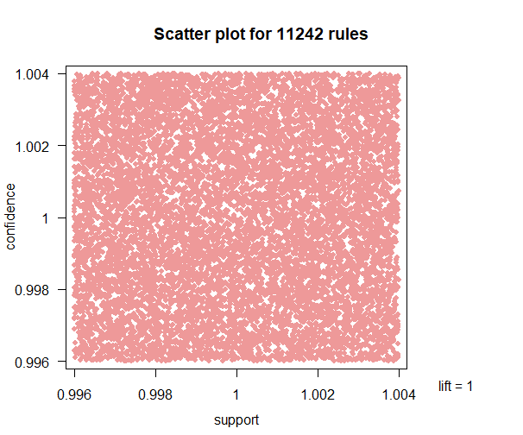

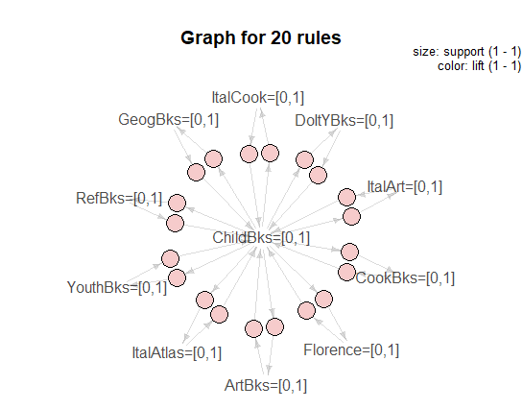

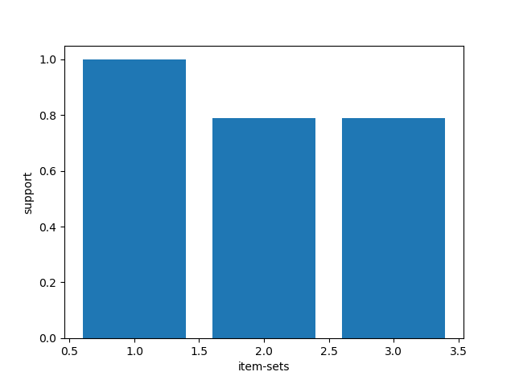

**MOVIES DATASET:**

#making rules using apriori algorithm

#keep changing support and confidence values for getting different rules.

#building model using apriori algorithm

arules_m <- apriori(movies,parameter = list(support=0.002,confidence=0.6,minlen=2))

arules_m

#set of 1105062 rules for support 0.002 & conf=0.6

arules_m2 <- apriori(movies,parameter = list(support=0.075,confidence=0.95,minlen=2))

arules_m2

#set of 1083077 rules for support=0.002 &support=0.004 and confidence as 0.8

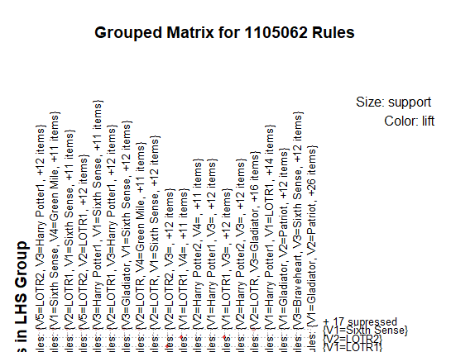

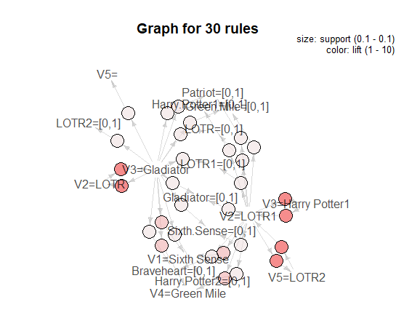

**MOST FREQUENT ITEMS BASED ON SUPPORT** 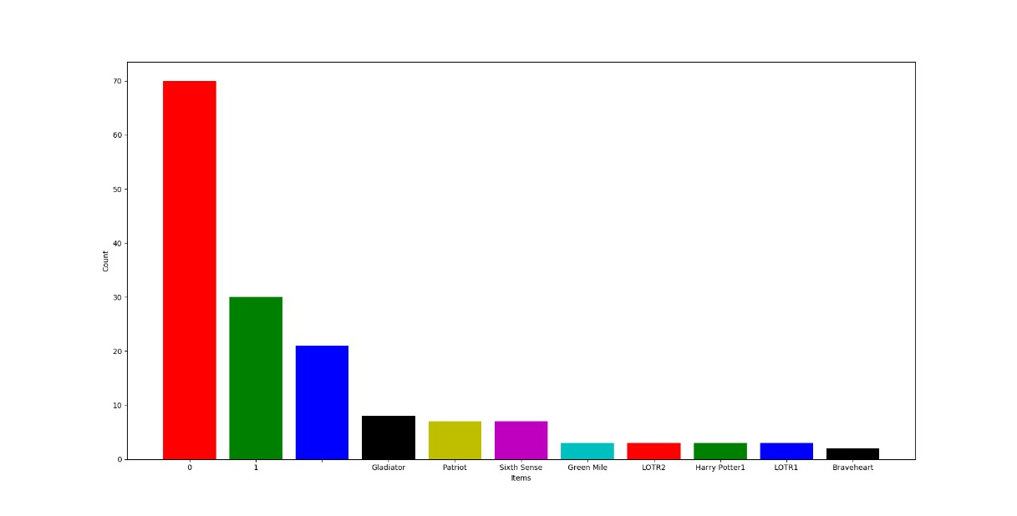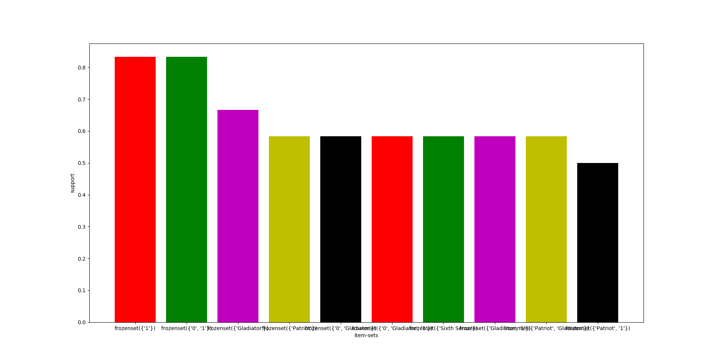

**PHONE DATASET:**

making rules using apriori algorithm

keep changing support and confidence values for getting different rules.

#building model using apriori algorithm

arules_p <- apriori(phone,parameter=list(support=0.002,confidence=0.6,minlen=2))

arules_p

#set of 10505 rules

arules_p1 <- apriori(phone,parameter=list(support=0.002,confidence=0.75,minlen=2))

arules_p1

#set of 10219 rules

arules_p2 <-apriori(phone,parameter=list(support=0.002,confidence=0.9,minlen=2))

arules_p2

=> there is no change in the value further with the change in the confidence and support values.

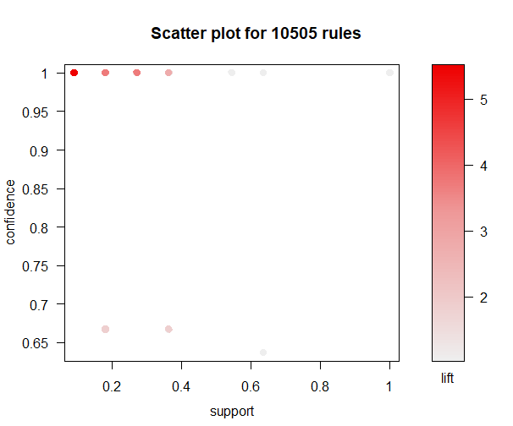

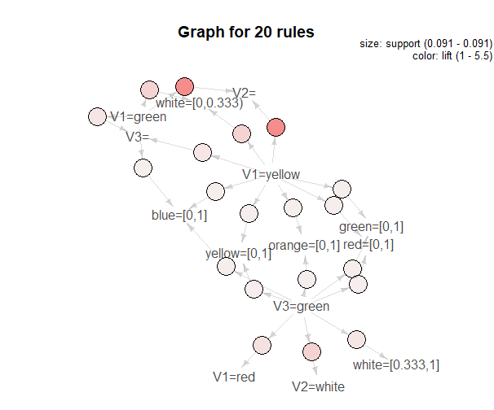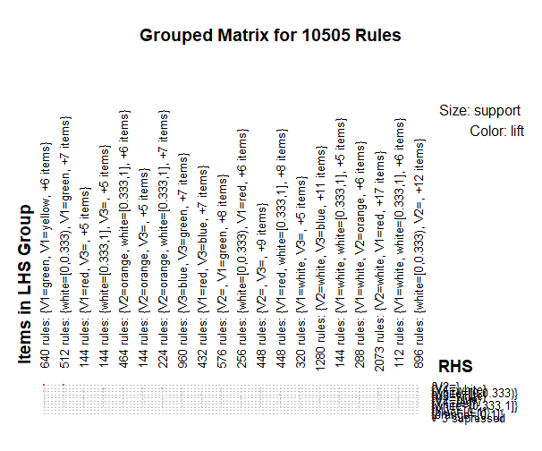

**BARPLOT OF TOP 10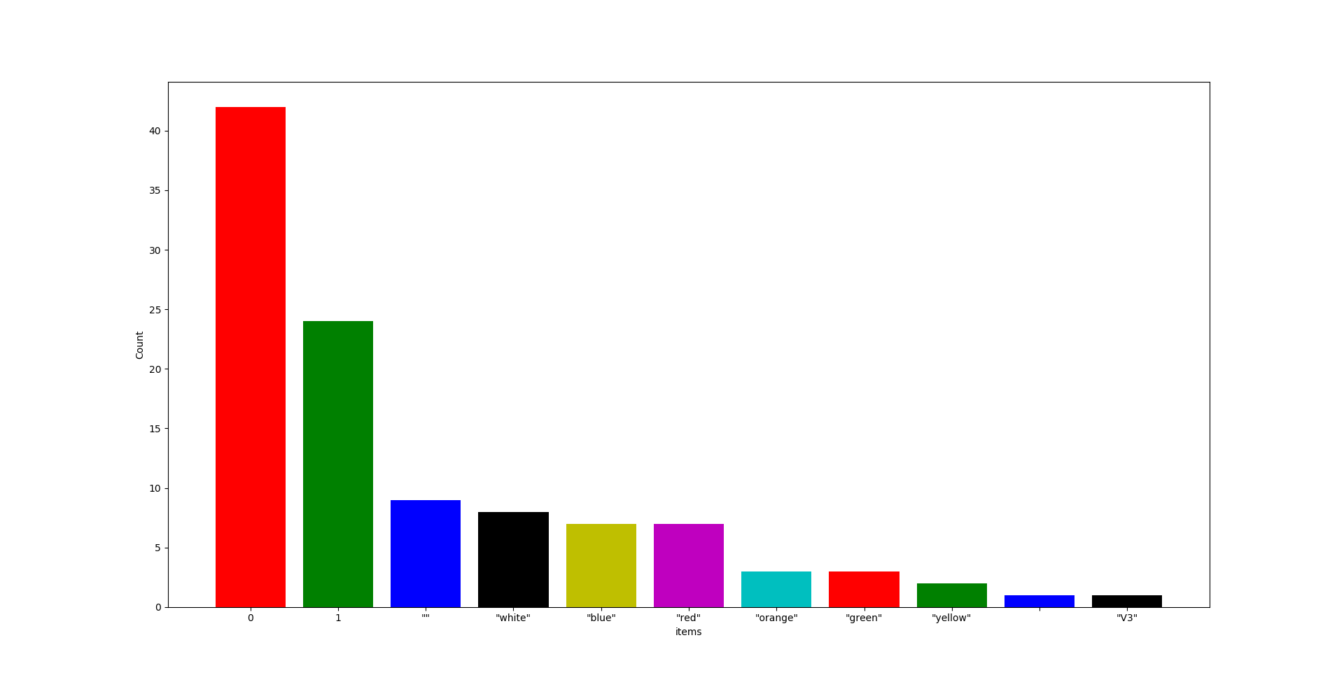BARPLOT FOR MOST FREQUENT DATA BASED ON SUPPORT :**

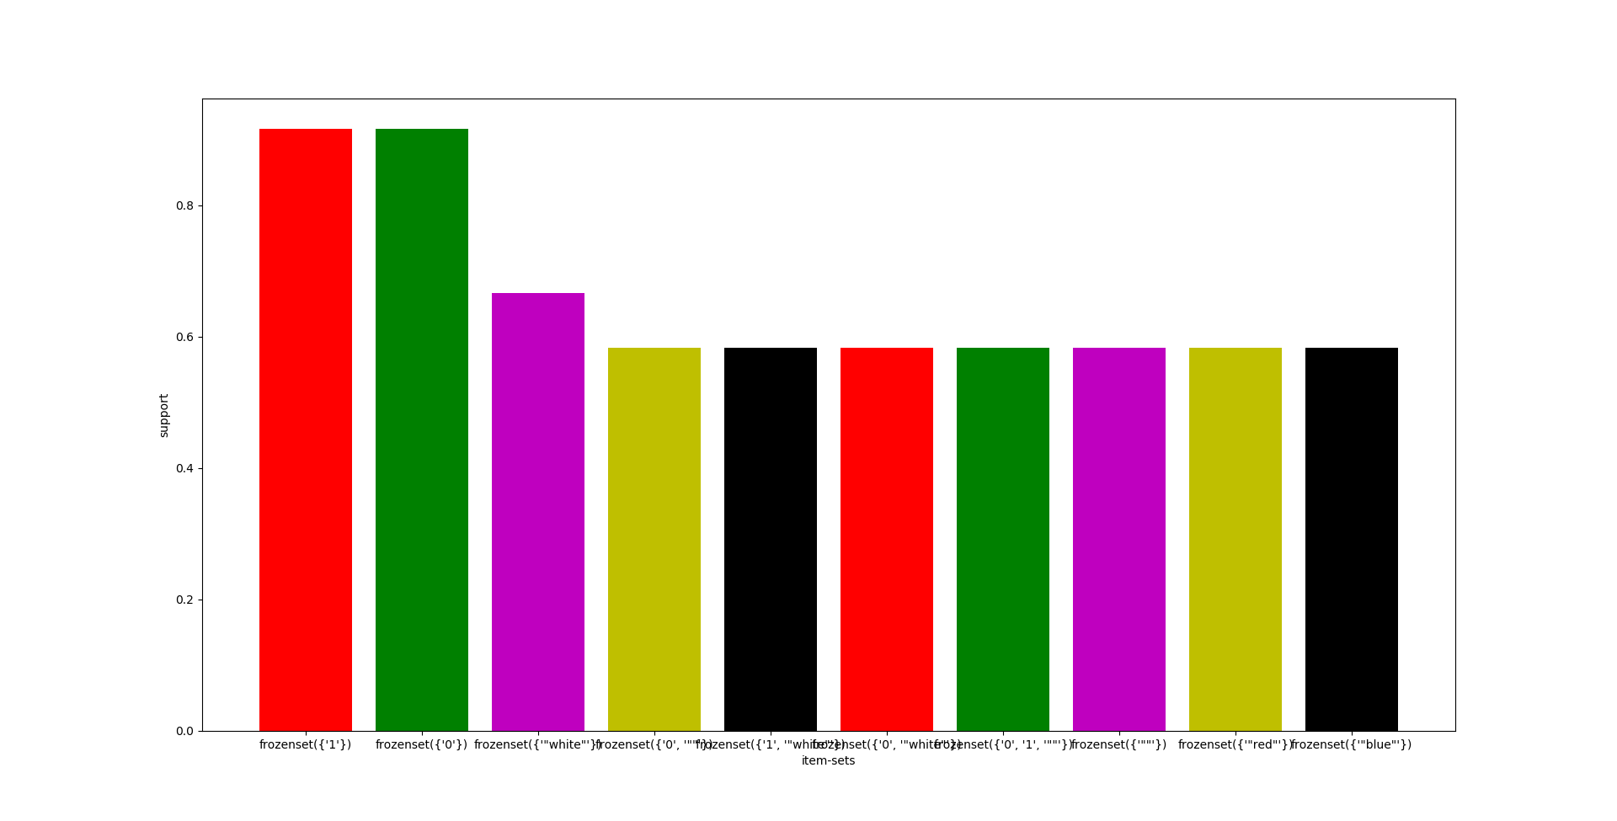

**TRANSACTION_RATAIL1 DATASET:**

in this transaction_retail1 there are lot of Na values in spite of removing all the Na values or omitting the Na values, here I will continue with the original dataset because of lot of Na values if remove them we will miss 4 lakhs plus records.

=>making rules using apriori algorithm

=>keep changing support and confidence values for getting different rules.

arules_t <- apriori(trans1,parameter=list(support=0.002,confidence=0.5,minlen=2))

arules_t

#set of 1415 rules

arules_t1 <- apriori(trans1,parameter=list(support=0.002,confidence=0.95,minlen=2))

arules_t1

#set of 995 rules

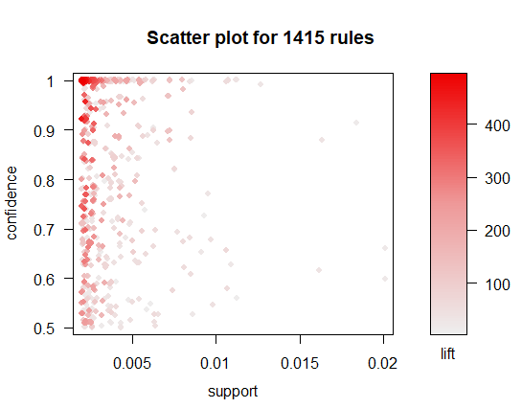

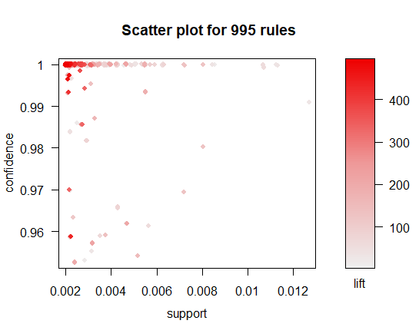

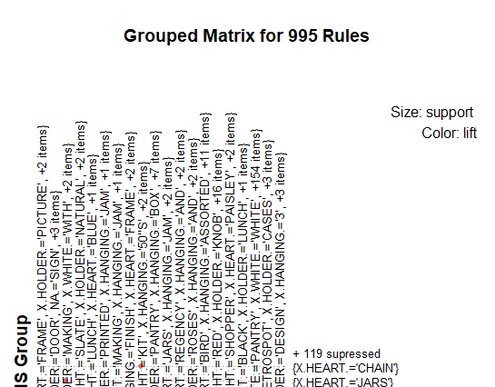

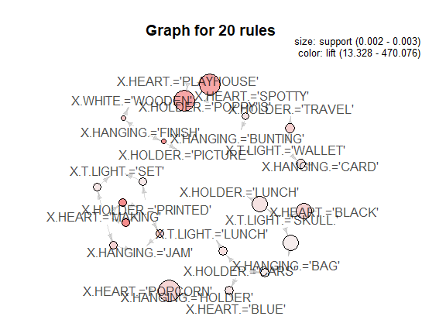

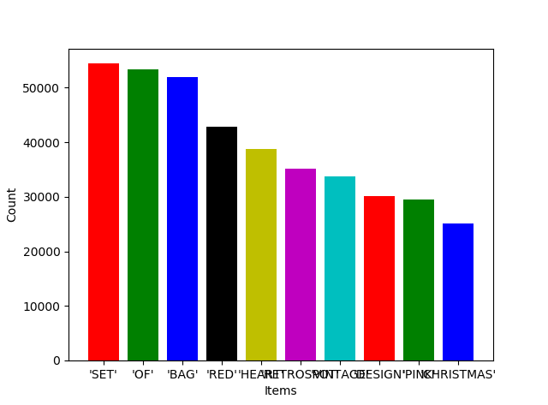

**Most frequent items:**